## THE TRAFALGAR SURGERY

**10 TRAFALGAR AVENUE**

**LONDON**

**SE15 6NR**

**Tel: 020 7703 9271**

www.thetrafalgarsurgery.co.uk

## Opening Times

#### Our reception desk and telephone lines are open

#### Mon – Fri from 08.00 AM to 6.30 PM.

#### Extended Opening Hours

#### To accommodate working patients, we offer appointments outside of our usual opening hours on Wednesday evenings (until 7.30 pm)

**Out of Hours**

**FOR MEDICAL ADVICE WHEN WE ARE CLOSED**

**TELEPHONE (NHS) 111**

**FOR MEDICAL EMERGENCIES INCLUDING LIFE THREATENING CONDITIONS**

**TELEPHONE FOR AN AMBULANCE ON 999**

**THE TEAM**

**CONTRACT HOLDERS**

**Non training/teaching practice**

**Dr Nadine Maniani**

**Partner**

**Female (Lille 1995)**

**-------------------------------------------------------------------------------------------------------------------------------**

**Practice Manager Assistant Practice Manager**

**Laura Nagi Diane Prescott**

**We have a range of clinical and administrative staff, including practice Nurse, Health Care Assistant, Secretaries and Receptionists.**

**TO REGISTER WITH THE PRACTICE.**

You need to live within the Practice catchment area to register with the Practice (see map attached). Only patients living within the inner boundary will be able to register with the Practice. However, if you are a registered patient with us and you move to an area that falls within the outer boundary, you will be able to remain on the Practice List. If you move outside of the outer boundary, you will be asked to register with another G.P. closer to where you live.

To process your registration, you will need to provide us with proof of address, a valid NHS number if you have one and Photo ID. Please complete a registration form and health questionnaire and hand it in at reception. You will be asked to book an appointment for a health check, following which the registration process is complete. The New Patient Health Check is very important as it will enable the Doctor to assess your health needs.

**Clinics and Services Available by Appointment**

**Antenatal, Asthma, Child Health, Diabetes, Family Planning and Travel. Please enquire at reception for dates and times of clinics.**

# Making an Appointment to See a Doctor

**Appointments can be pre-booked up to 14 days in advance and a limited amount of appointments are available each day for on the day booking. Please telephone at 8 am if you wish to make an on the day booking. You can book appointments online by registering with the Practice for online access. Please ask at reception for details.**

* **On Wednesday’s we offer late evening (after 6.30 pm) appointments and these can be booked 48 hours in advance (8 am on Monday mornings).**
* Appointments for the Nurse and Health Care Assistant are made in advance.

Home Visits

**With all its facilities, the surgery is the best place to be seen. However, if you are too ill to come to the surgery and are requesting a home visit, please make your request preferably during the morning or as soon as possible.**

**HOW WE USE PATIENT HEALTH INFORMATION**

**We respect your right to privacy and keep all your health information confidential and secure. It is important that the NHS keeps accurate and up-to-date records about your health and treatment so that those treating you can give you the best care possible.**

**This information may be used for management and audit purposes. However, it is usually only available to, and used by, those involved in your care. You have the right to know what information we hold about you. If you would like to see your records, please put your request in writing to the Practice Manager.**

**YOUR RIGHTS**

**Absolute confidentiality and courtesy from all staff. Access to your medical records by writing to the Practice Manager who will organise this for you. Telephone calls answered promptly by a receptionist. Same day appointment if you are acutely ill or telephone advice from the doctor. An explanation if you have to wait over 30 minutes. Repeat prescriptions available within 48 working hours. You also have the right to express a preference to see a Practitioner of your choice.**

**YOUR RESPONSIBILITIES**

**To treat our staff with courtesy. To be considerate to other patients in the building. To be courteous to our home visiting staff and out of hours emergency service. To cancel appointments if you cannot attend. To respect our premises and our building. Please do not eat on the premises. Please do not bring bicycles/prams inside the building. To learn how to treat your minor illnesses and to keep your prescribed and basic household medicines e.g. painkillers, cough mixtures etc… in a safe place.**

**PLEASE NOTE:  We are a multi- racial Practice and Racism, IS NOT tolerated.**

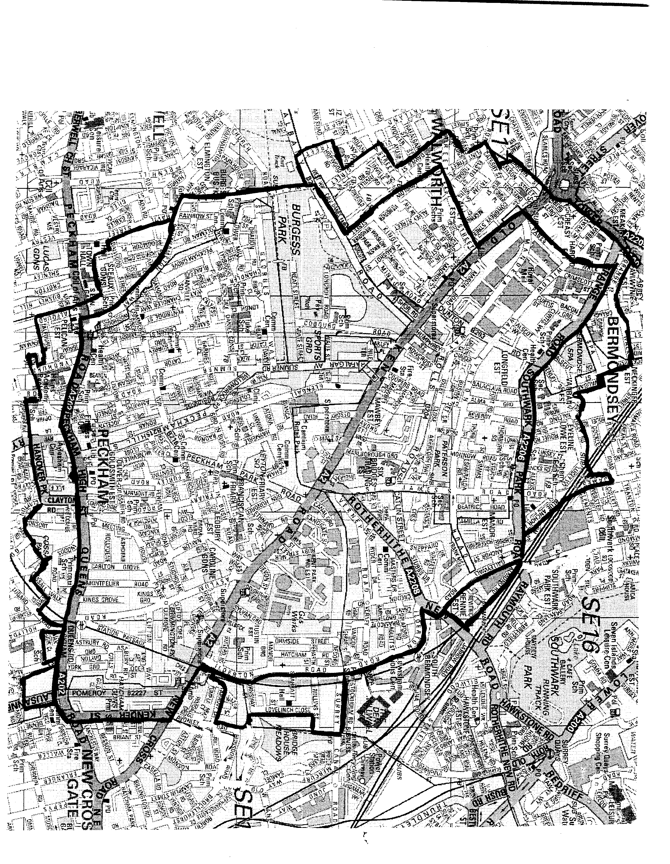

# Repeat Prescriptions

**For repeat prescriptions, we require 48 hrs notice (excluding weekends). The easiest way to do this, is to sign up to (nominate) a chemist to have your prescription sent to them electronically (EPS Service),**

**You may order repeat prescriptions by bringing your request in to reception, by posting it through the letter box when we are closed or by using the postal service with a stamp addressed envelope (please allow one week’s notice if using the postal service).**

**You may also order/collect your prescription with the help of either Ling’s Chemist, Asda Pharmacy or Tesco Pharmacy all on The Old Kent Road. Please ask at reception for details**.

**Medication Reviews**

**From time to time, you will be requested to see the Dr for a medication review. These reviews are important, so please assist us by complying with such requests.**

**Patient Participation**

**From time to time, you may be asked to complete a questionnaire to find out your views on our services. If you receive one, please complete it as your views are important to us.**

**We also have a Patient Participation Group at the Practice which meets once a quarter to provide feedback and to discuss the way in which the surgery operates. Please contact the Practice Manager if you are interested in joining the Group.**

Online Patient Access

You can access limited sections of your medical records, order a repeat prescription and book appointments online by registering with the Practice for online access. Please ask at reception for details.

**Disabled Access via a ramp is available and the services of Doctors and Nurses can all be accessed on the ground floor as we do not have a lift on the premises.**

**CONCERNS AND COMPLAINTS**

We aim to provide a high quality service. If for any reason you are not happy with the service provided, please raise it with a member of staff and they will supply you with a copy of our Complaints Procedure and a Complaint Form. When completed this will be forwarded to the Practice Manager for a response.

**If you don’t feel comfortable with raising your concern with us, you may alternatively contact NHS England**[**england.contactus@nhs.net**](mailto:england.contactus@nhs.net)

PLEASE NOTE: We are a multi- racial Practice and Racism, IS NOT tolerated.